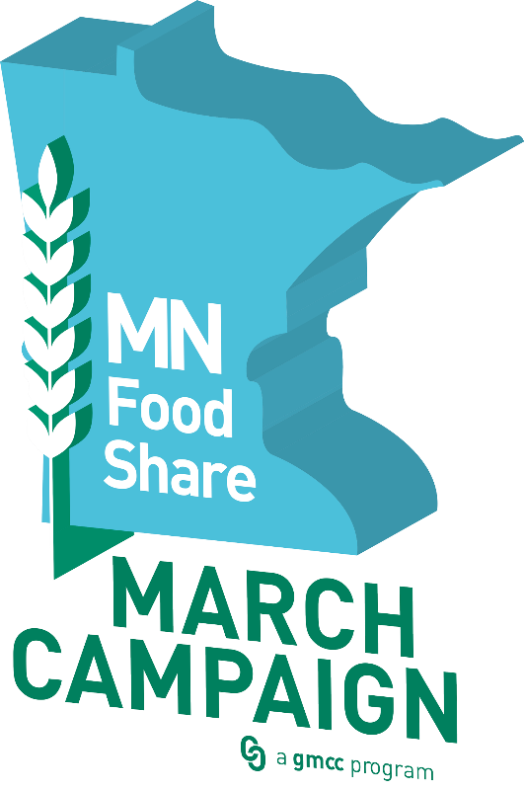
2026 March Campaign
Food Shelf
Reporting Guidelines

As a March Campaign participant, you are asked to report totals received at your food shelf two times during the campaign. This reporting assists us in tracking the impact and response to the March Campaign and is a part of determining your FoodFund financial allocation amount.
March Campaign dates: Sunday, March 1 – Monday, April 6

2026 reporting dates:
- March 15, 2026 (mid-Campaign report = amount raised up to report date, can be a rough estimate)
- April 27, 2026 (final Campaign report = cumulative total collected (3/1/26-4/6/26)
Guidelines:
- Weigh food/non-food items donated to your food shelf during the March Campaign.
  - DO count non-food items donated that are distributed via your food shelf.
  - DO count rescued/donated items from local grocers, restaurants, etc.
  - DO NOT include food/items purchased from your food bank or food received via TEFAP or other grant programs. The purpose of the March Campaign is to encourage engagement of communities with their local food shelf and increase the influx of food and fund donations to food shelves.
- Count dollars received by your food shelf during the March Campaign.
  - DO count dollars donated to your food shelf and received during the March Campaign that will be used to purchase food/other food shelf items for food shelf clients.
  - DO count any dollars raised at events benefiting your food shelf that occur during the March Campaign. Actual event must take place during the March Campaign and donations/ticket fees, etc. must be collected by the end of the day on 4/6/26.
  - DO NOT count grants or funding received by your food shelf to support general operating or other programming expenses during the campaign period.
- Report twice during the campaign:
  - March 15, 2026 – report total dollars and pounds collected up to 3/15/2026
    - This number does NOT affect your financial allocation. We use this information to help us gauge how the March Campaign is going. You may provide a rough estimate.
  - April 27, 2026 – report cumulative total dollars and pounds collected 3/1/26-4/6/26
    - Failure to report final numbers by end of day on 4/27/26 could result in your agency not being eligible for a FoodFund financial allocation.
Report online: gmcc.org/mc-reporting Report by phone: 612-276-15648

